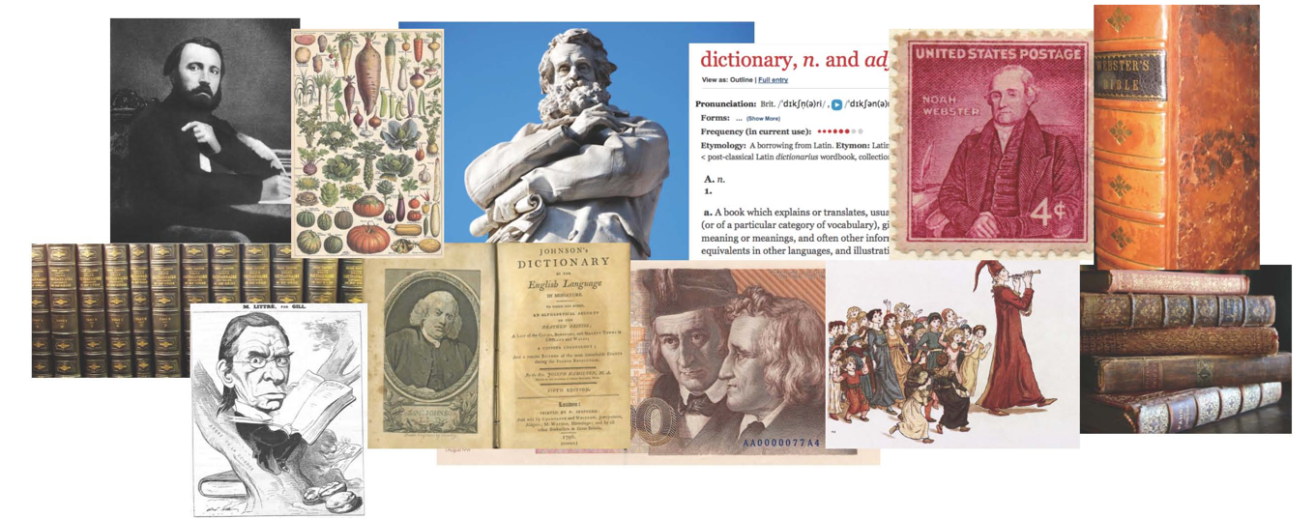


The fifth international symposium on History of English Lexicography and Lexicology (HEL-LEX5)
16–18 February 2017

Registration Form

Contact Information
Name:
Affiliation:
Address:
Phone:
E-Mail:

Registration fee
Please enter the number of items you want to book in the field on the left. The total amount is calculated automatically when you leave the field.

Registration fee
0 | Full (120 CHF) | 0 | CHF
0 | Student (60 CHF) | 0 | CHF
Conference dinner (62 CHF)
0 | Meat (French onion soup, Beef ‘Stroganoff’, Dessert) | 0 | CHF
0 | Fish (French onion soup, Pikeperch filet, Dessert) | 0 | CHF
0 | Vegetarian (French onion soup, Grilled vegetable skewer, Dessert) | 0 | CHF
The fee includes soft drinks, coffee or tea, and a glass of wine. If you have special dietary requirements, please select one of the options above and note the requirements on the next page.
Excursion
0 | City tour Saturday, 18 February, afternoon (10 CHF) | 0 | CHF
0 | Basler Papiermühle, Sunday, 19 February (100 CHF) | 0 | CHF
Opening reception
0 | Opening reception Wednesday, 15 February, evening | free
TOTAL |  | 0 | CHF
Special dietary requirements

If you have any dietary requirements, please note them down in the following field. The menu will be adapted for you accordingly:

Please fill in this form and e-mail it to hellex5@es.uzh.ch no later than 10 December 2016.

The total registration fee needs to be transferred to the following bank account:

Bank:
PostFinance AG
Mingerstrasse 20
3030 Bern

Account.: 31-878400-3
IBAN-No.: CH08 0900 0000 3187 8400 3
BIC/Swift: POFICHBEXXX
Beneficiary: Rechnungswesen der Universität Zürich, HEL-LEX 5, Zürich

Payment reference: HEL-LEX 5

Please do not forget to give your name along with the payment reference. Participants are requested to ensure that they cover all possible bank transfer fees.

